Transition Activity – Programming a Racing Game
Installing Scratch 1.4

First, head to https://scratch.mit.edu/scratch_1.4
Then, click on the download file and install the application on your computer.
Once installed, click the icon to open it!

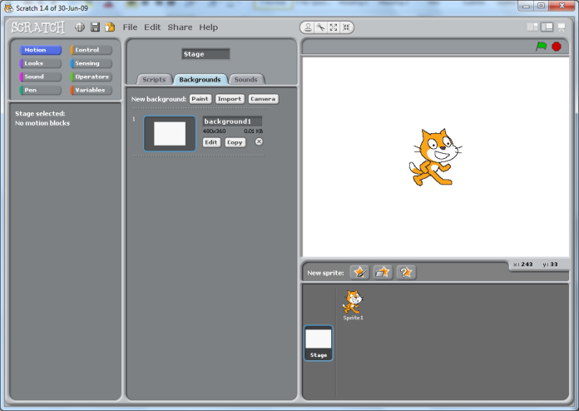
Drawing Your Track
Click on stage, then background and then draw your track using the paintbrush. Choose a big paint brush size and fill the background green.
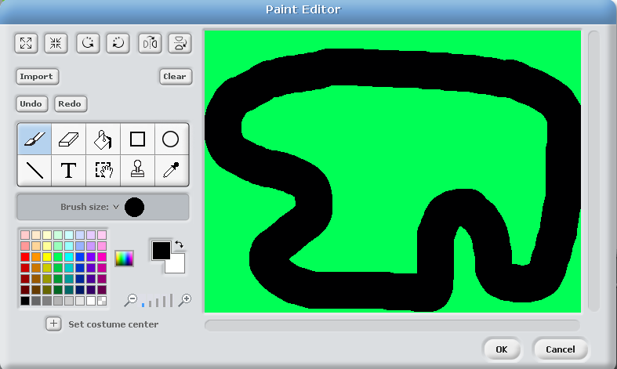

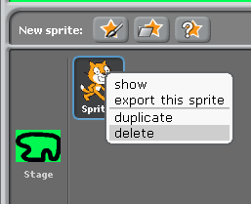
Creating Your Racing Car

Next you need to delete the cat sprite by right clicking on it and choosing delete.

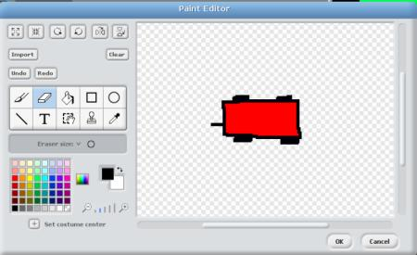
Now you need to draw your racing car. To do this click on the PAINT NEW SPRITE button and draw a car (pointing to the right) in the paint editor.
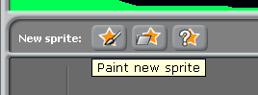

Draw it Pointing Right

Shrinking Your Car
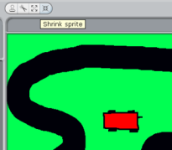
Once you have created the car, you need to shrink it so it fits on the track. To do this, click on the SHRINK SPRITE button above the stage and then click on the car several times to shrink it down to size.

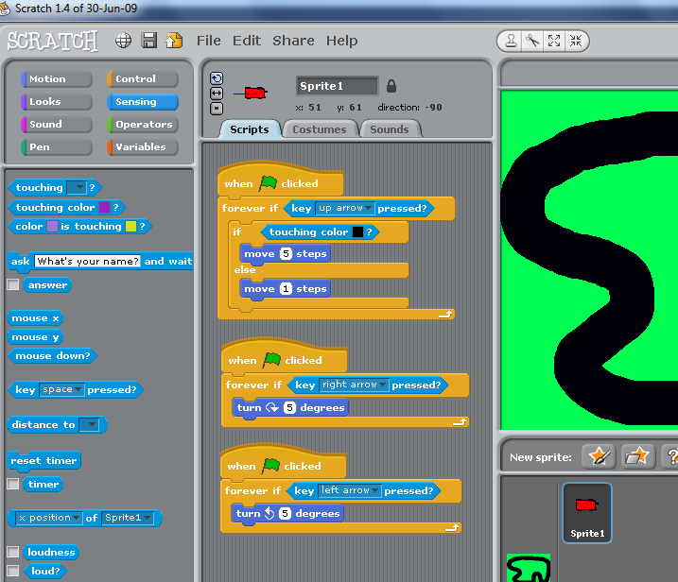
Programming Movement
Now you need to program the car. Select the car sprite first and then in the scripts area make the following blocks of instructions.

You need one to make the car move forward (faster on the track and slower on the grass). You need two more to program the car’s left and right movement.

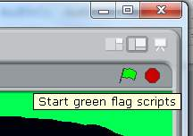
Playing Your Game
Now you are ready to play the game! Click on the green flag (top right hand corner of the stage) and use the arrow keys (that you just programmed) and play your racing game.

Adding a Scorecard:
You can easily develop this game by creating scoring items that the car has to pick up as it goes around the track. Let’s see how this can be done!
First, create a variable and name it ‘Score’.
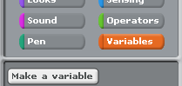
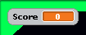

You know you have done it right when you see the ‘score card’ appear in the top left hand corner of the screen.
Adding Scoring Items
Now we can add some scoring items.
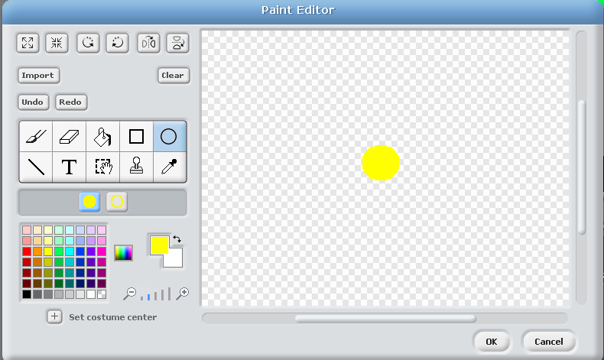
A scoring item is simply another sprite. Create a new sprite by clicking on the ‘New Sprite’ button (just below the stage).
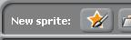

Then paint your own sprite. I have chosen to have a yellow dot as my scoring item but you can draw whatever you like. Try to keep it small though.
When you have finished you should be able to see your scoring object next to your other sprite.
Now you should be able to place it on the track wherever you like.

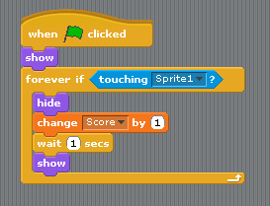
The sprite (scoring item) will not do anything on its own so we will have to program it.
Adding this script to your scoring item will mean that each time it comes in contact with the car (sprite 1):
- it hides
- the score increases by 1
- 1 second passes
- the scoring item reappears.

Adding more scoring items on your track
Adding more is just a matter of duplicating your ‘already programmed’ sprite.
You just need to right click on the sprite (shown under the stage) and select duplicate.
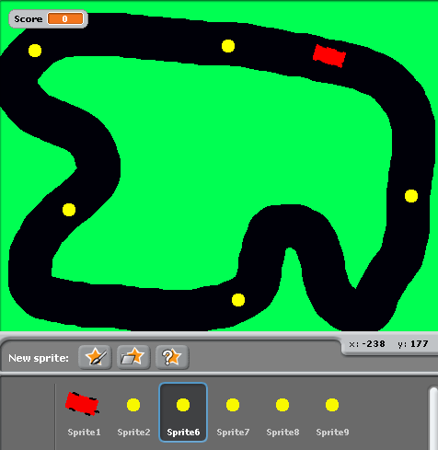
Then just drag and drop the sprites to different parts of your track.

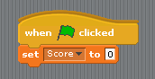
Resetting the score at the start of each game
To reset the score when the game begins you need to add this script into your program.
It will ‘set the score to 0’, when the green flag is clicked.

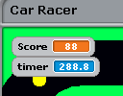
Creating a Timer
To add a little bit of drama to your game, you can try adding a timer.
This will mean that people can see what score they can achieve in a certain timeframe.
To add a time, you can use a readymade script. In the ‘sensing’ scripts, tick the timer box and create a script to reset the timer each time the game starts (green flag clicked).
…now enjoy your game!

Extensions
Make the game end (stop all scripts) when the timer reaches a certain number of seconds.
Make the car move automatically.
Create a second track and allow the user to change tracks if they press a certain keyboard key.
Delete the timer and create your own variable called timer, set it to 60 and program the timer variable to reduce by 1, every second, until it gets to zero. At this point, program the game to end (stop all scripts)
…anything else you can think might make the game even better!

