

**ParentPay - Our Online Payment Service**

​We are pleased to announce that we accept payments online for items such as dinner money, college trips and uniform. Using a secure website called ParentPay you are able to pay online using your credit / debit card or make cash payments at PayPoint stores. ParentPay is our preferred method of making payments to the college.

**What are the Benefits to Parents and Students?**

* ParentPay is easy-to-use and will offer you the freedom to make online payments whenever and wherever you like, 24/7
* The technology used is of the highest internet security available ensuring that your money will reach the college safely – offering you peace of mind
* Payments can be made by credit/debit card or also through PayPoint
* Full payment histories, balance alerts and statements are available to you securely online at anytime

**What are the Benefits to the College?**

* Creates more time to lend to educational support and the smooth running of the college
* Using ParentPay also ensures that all financial transactions are safe and secure - helping us to remove costs associated with us having to manage cash securely on the college premises
* The more parents that use ParentPay, the greater the benefit is to our college.

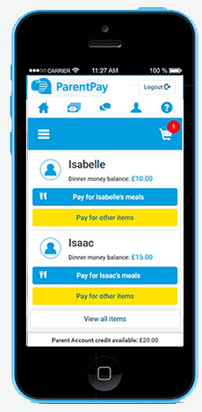

**How to Get Started with ParentPay**

* Visit www.parentpay.com
* Enter your Activation username and password in the Account Login section of the homepage. NB. These are for one-time use only, please choose your own username and password for future access during the activation process
* Provide all the necessary information and choose your new username and password for your account - registering your email address will enable us to send you receipts and reminders
* Once activation is complete you can go to straight to Items for payment, select which item(s) you want to add to your basket and proceed to complete your payment

If you have any questions, please contact Sidmouth College on 01395 514823 and choose option 4. For more information, visit: <https://www.parentpay.com/parents/>