Department:
See Drama and History example attached.  Please keep information concise and no more than 1 A4 side. | Make information KS3 generic, if possible.  Deadline: Friday 11th June
- Introduction: How are students assessed?

In Computer Science, students are assessed in the following areas:
- Understanding of Computer Science Theoretical Topics
- Programming & Problem Solving

Students carry out summative assessments at the end of each topic (roughly after 6-7 weeks).
Students also carry out formative assessments, during each topic.
In addition, students regularly take low stakes quizzes, to help them reinforce their understanding of previous teachings (retrieval practice and interleaving).

Data collected from the summative assessments, in the form of a percentage of correct answers achieved, will be used to make an objective judgement about their understanding/learning at that time. In addition, data collected from the formative assessments and regular low stakes quizzes, will also be taken into consideration.

- What areas are students assessed in?
Understanding of Computer Science Theoretical Topics | Programming & Problem Solving
Year 7  Introduction to the School System  Computer Hardware  Year 8  Data Representation  Digital Citizenship  Year 9  Networking  Computer Science History | Year 7  Introduction to Programming (via Scratch)  HTML (Writing Websites)  Programming Computer Games (Level 1)  Year 8  Programming in Python (Level 1)  HTML & CSS (Writing Websites)  Programming Computer Games (Level 2)  Year 9  Programming in Python (Level 2)  HTML, CSS & JavaScript (Writing Websites)  Programming Computer Games (Level 3)

- How will students track their progress?

Students will track their progress via their dashboard page on the sidmouthcs.com website.
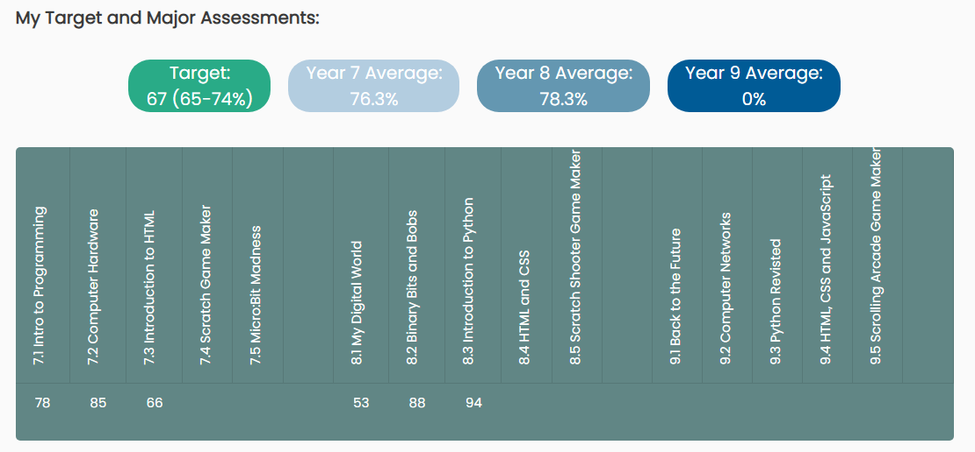
Following each topic, students will be able to view their percentage and compare it with the expected percentage range for their ability.

KS3 Percentage Assessment – Subject Information

