Department: English
See Drama and History example attached.  Please keep information concise and no more than 1 A4 side. | Make information KS3 generic, if possible.  Deadline: Friday 11th June
- Introduction: How are students assessed?
The students are assessed twice in each half-term. The assessments are marked using assessment sheets that link KS3 to KS4 in terms of the skills descriptors. The units of work and the focus for assessments are designed to move the students on and up from the KS2 SATs in order to prepare them for the skills and format of GCSE English Language and Literature.

- What areas are students assessed in?
The students are assessed in reading, writing and speaking and listening.

The reading assessments are designed to extend the skills that they have developed in their SATS in steps from Year 7 through to Year 9 so that they are able to write an extended analytical essay by the end of Year 9.

The writing assessments are designed to develop their understanding of, and use of, key writers’ techniques in terms of language in Year 7 and moving to structure in Year 8 and then into more sophisticated techniques such as dramatic irony in Year 9.

The reading and writing assessments complement each other in the development of the key GCSE skills.

The speaking and listening focus on three key areas: drama, group discussion and individual presentation. They complement the reading and writing skills of the KS3 curriculum allowing students to develop their ability to write a persuasive speech, writing to argue, character role play, and presenting a group of poems.

- How will students track their progress?
The students are able to track their progress through the assessment sheets that are filled in by the teacher marking the assessment. The teacher will tick the skills that they are using securely and circle or highlight the skills that they are not secure in. The skills are divided into four stages: 1-2, 3-4, 5-6, 6-7; this is a simplified adaptation of the previous assessment sheets to allow students to see the stages that they need to move through and the key skills that they should be focussing on. In Year 7, the assessment sheets will only go up to 6-7, moving to 7 -8 in Year 8, and 8-9 in Year 9.

The new percentage reporting equates to these stages – see below.

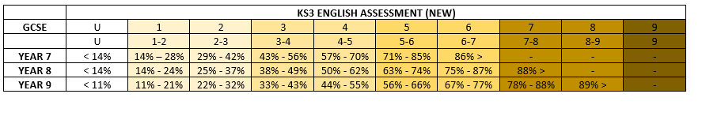

KS3 Percentage Assessment – Subject Information

