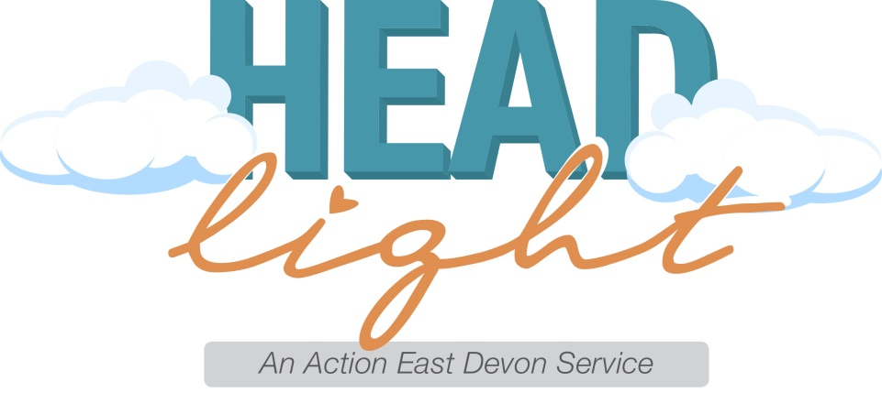
Headlight is still here to help
At Headlight we want you all to know that we are still here and open to support young people with their emotional wellbeing and mental health issues.
During the coronavirus lockdown we are supporting young people in the following ways:
- Weekly check ins with our referrals- Just a 5 minute check-in can mean the world to some young people it helps remind them that someone is thinking of them and is there to talk if they need to.
- 121 ‘meetings’- During the weekly check in our Mental Health Support Workers arrange 121 meetings with the young person. This can be done via phone call, video call or even a pre-arranged text conversation for those that find phone calls challenging.
- Group sessions- We are currently able to run our group sessions online. Much like our typical Headlight sessions these are a mix of facilitated discussion, talking and sharing with activities to support young people with their wellbeing and mental health. We run these on our normal group days and times. Once registered with a group, the link to these groups is shared.
Ottery St Mary –Monday evenings 6:30pm alternative weeks for 13-18 year olds and 18-24 year olds
Axminster – Thursday evenings 6:30pm alternative weeks for 13-18 year olds and 18-24 year olds.
We have paused our opening of the new Sidmouth based sessions until the restrictions on social distancing are lifted.
- YouTube and social media- The Headlight team are putting out regular short videos for young people on our YouTube channel @Headlight Action East Devon. These give hints and tips on mindfulness techniques for young people and ways for young people to support themselves through this time as well as some short reviews of other apps that can be used.
Please also check out Facebook and Instagram pages @HeadlightEastDevon.
Referrals can still be made in the usual way via our online form on the website www.actioneastdevon.org.uk and general enquires can be made at headlight@actioneastdevon.org.uk
We look forward to delivering our face to face support as soon as we are able to do so.
Thank you from Headlight and the Action East Devon Team

