Welcome to Sidmouth College Mathematics Department

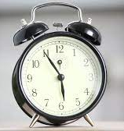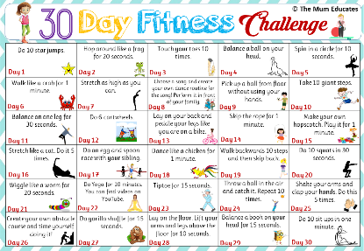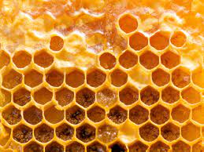
Whether it’s your timetable for the day, transport, shopping, cooking, keeping fit or doing a job, Maths comes into almost every activity you take part in each day. You may also see natural or man-made objects that show some Mathematics.

For your Maths activity to day we would like you to make a record of the Maths you use or see in your everyday activities. This might include a written record, pictures and/or video clips.

Submit your record to us – the ones that surprise us, impress us or make us laugh the most will win prizes.

