Department: Music
See Drama and History example attached.  Please keep information concise and no more than 1 A4 side. | Make information KS3 generic, if possible.  Deadline: Friday 11th June
- Introduction: How are students assessed?
The predominance of assessment at KS3 is verbal, due to the fact that the learning takes place in time and space rather than on paper. Sometimes videos are taken as a snapshot of evidence of how students are making progress towards specific targets. Often this will be combined with a conversation (also captured on video) to enable students to make progress towards stated outcomes.

As students work on their music, the conversations had, and the snapshots taken, contribute toward the teacher assessing work as ‘Towards Pass’ (worth 1 point), ‘Pass’(worth 3 points), ‘Merit’ (worth 4 points) or ‘Distinction’ (worth 5 points) across 9 Progress Indicators, each one of which has a slightly different percentage weighting. The table below shows you the progress indicators, their descriptions, and the percentage weighting.

- What areas are students assessed in?
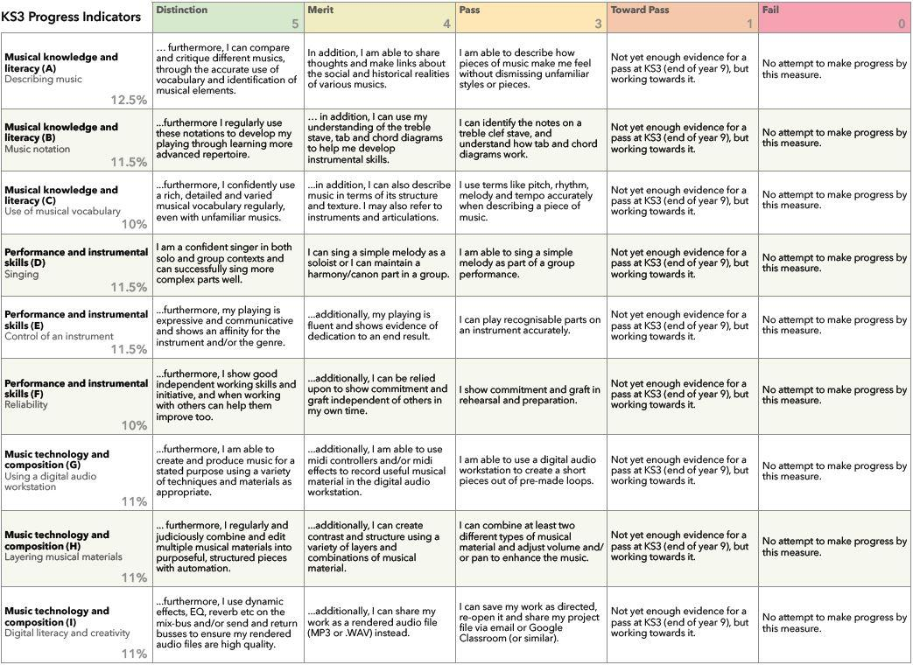
N.B. The above rubric is still undergoing development and may change subtly from what is written there. The descriptions are intended as a qualitative guide to the sort of work students are likely to produce, and are therefore neither exhaustive nor binding, allowing space for teacher/assessor discretion.

- How will students track their progress?
Once we have fully rolled out this system, it is intended that a continuous rubric such as the one above will be maintained by the students in Google Classroom. Summative feedback such as that at the end of a project will then lead to students updating their own rubric as directed, so that if required, percentage marks can be understood in more detail.

It should be noted however, that the most useful feedback is the formative feedback that a student receives in the moment. This may be from a teacher, but may also be from a partner or group member (peer feedback). When working towards a given outcome, students will be constantly giving and receiving feedback through genuine, 2-way interactions and conversations due to the fact that most of the work students will undertake in music will be practical or technical and rely heavily on cooperative problem solving. With this model then, tracking progress is less about writing down reflections and targets in any formalised way, but maintaining constant discussion about how things are going, and how they can be improved.

KS3 Percentage Assessment – Subject Information

