Religious Education Year 6 Work

Hello Year 6 students – we are looking forward to welcoming you to Sidmouth College.
Your task is to design a Peace Garden where different people can meet and talk or enjoy the stillness.
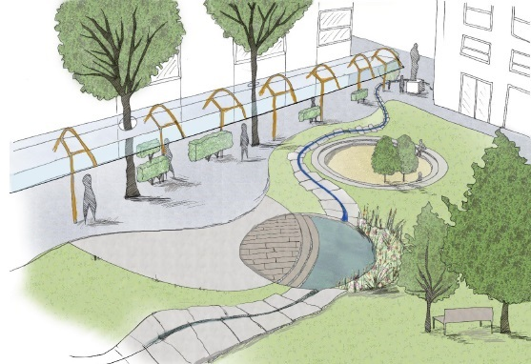
Think About:
- Making a quiet space where people will feel calm – think about colours, water, shapes. Could you include symbols?
- A meeting place where people can go to talk about difficult issues or make friends
- A place with something for young and old
- A place where people can remember people who have died
- A place where people can leave messages of hope – on a wall, on pebbles, on bunting…use your imagination
- A place where food can be grown and shared with the community

You can use:
- Pens, paints, pencils and draw your design on paper
- Plan it on the computer – you could make a Power point.
- Create a model of your design
- Label your design to show what each part is for.

