Remote education
Subject: DRAMA
Year Group: 7
Week commencing | Topic | How will the new content be delivered? | What activities need to be completed?
Monday 2nd November | Darkwood Manor | P:/Remote Education Work/ Drama/Year 7  Year 7 Darkwood Manor resources | - Respond to the picture stimulus What can you see? What is unusual? [mind map]  - Listen to music [Describe the atmosphere and mood it creates]  - Describe the Horror genre and list the features
Monday 9th November | Darkwood Manor | P:/Remote Education Work/ Drama/Year 7  Year 7 Darkwood Manor resources | - Write a list of ingredients that would make a good horror story work
Monday 16th November | Darkwood Manor | P:/Remote Education Work/ Drama/Year 7  Year 7 Darkwood Manor resources | - Look at the invitation to stay the night in the Manor  - Write a conversation between 2 friends one keen to take the challenge and the other not happy – How does the keen one convince the fearful one to take the challenge?
Monday 23rd November | Darkwood Manor | P:/Remote Education Work/ Drama/Year 7  Year 7 Darkwood Manor resources | Preparing to visit the Manor  - Write a list of what you would take with you if you were going to stay the night at the Manor and tell me why they are important  - Imagine you are terrified and create a mind map or create an image with thought bubbles about your fears
Monday 30th November | Darkwood Manor | P:/Remote Education Work/ Drama/Year 7  Year 7 Darkwood Manor resources | The night at the Manor  - What does the word suspense mean and how can you create it for an audience?  - Read the start of this short story  - Create an ending to the story keeping the same atmosphere and suspense
Monday 7th December | Darkwood Manor | P:/Remote Education Work/ Drama/Year 7  Year 7 Darkwood Manor resources | Write a news report with the following headline  ‘Darkwood Nightmare’
Monday 14th December | Darkwood Manor | P:/Remote Education Work/ Drama/Year 7  Year 7 Darkwood Manor resources | Examine the image and look at the skills/ Genre/ Key effects and Learning Habits  Tell me what you have learned about them in this topic

Year 7 Darkwood Manor Lessons and resources
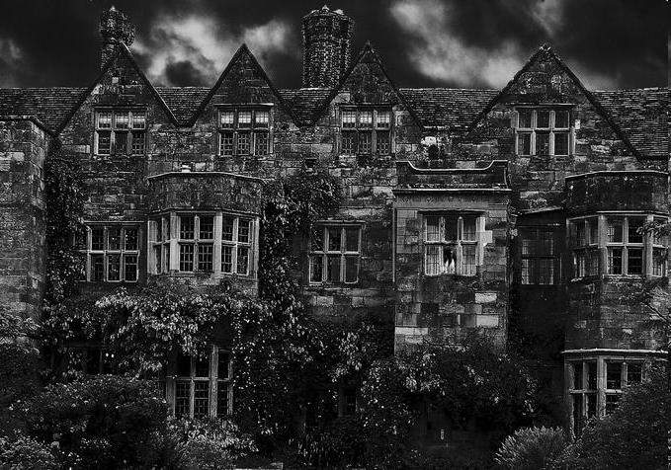
Lesson Mon 2nd November Darkwood Manor
Look at this picture of Darkwood Manor and listen to this music
https://www.youtube.com/watch?v=XCKQgJ0Eqlg
- Respond to the picture What can you see? Describe the house. What is unusual? [mind map]
- Listen to the music [Describe the atmosphere and mood it creates]
- Describe the Horror genre
Lesson Monday 9th November Ingredients for Horror task

Write a list of ingredients that would make a good horror story work

Lesson Monday 16th November Tasks
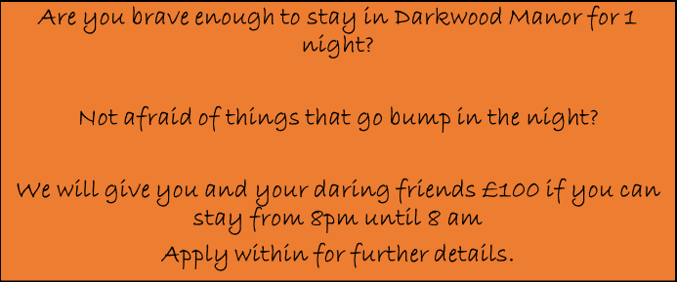

Look at the invitation to stay the night in the Manor
- Write a conversation between 2 friends one keen to take the challenge and the other not happy – How does the keen one convince the fearful one to take the challenge?

Lesson Monday 23rd November Preparing to visit the Manor Tasks
- Write a list of what you would take with you if you were going to stay the night at the Manor and tell me why they are important
- Imagine you are terrified and create a mind map or create an image with thought bubbles about your fears

Lesson Monday 30th November End the story Tasks
- Tell me what the word suspense means and how you can create it for an audience
- Read the start of this short story
- Create an ending to the story keeping the same atmosphere and suspense
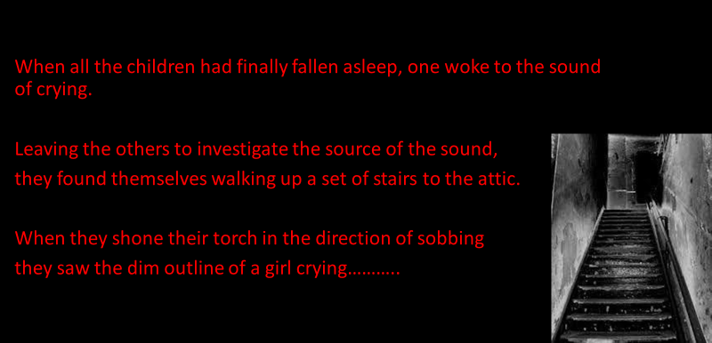
Lesson Monday 7th December News report Task
Write a news report with the following headline
‘Darkwood Nightmare’
Lesson Monday 14th December Reflection and evaluation
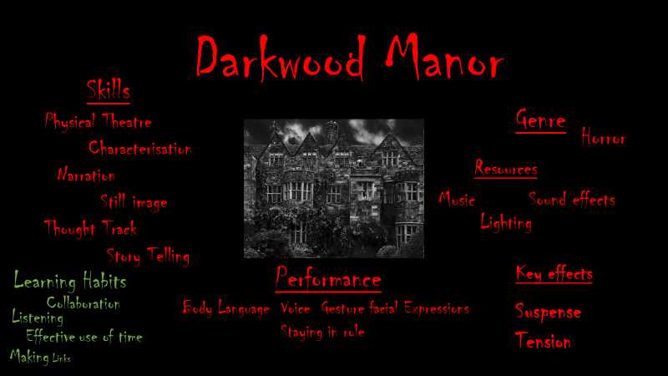
- Examine the image and look at the skills/ Genre/ Key effects and Learning Habits
- Tell me what you have learned about them in this topic

