Remote education
Subject: DRAMA
Year Group: 8
Week commencing | Topic | How will the new content be delivered? | What activities need to be completed?
Monday 2nd November | Gangs | P:/Remote Education Work/ Drama/Year 8  Year 8 Gangs  resources | - Respond to the picture stimulus – what do you think of when you see a gang?  - Create a mind map of reasons for joining a gang  - Read the first part of Sam’s story
Monday 9th November | Gangs | P:/Remote Education Work/ Drama/Year 8  Year 8 Gangs  resources | - Read the next part of Sam’s story  - Write a diary entry by Sam describing his new life and his feelings.
Monday 16th November | Gangs | P:/Remote Education Work/ Drama/Year 8  Year 8 Gangs  resources | - Research teenage gangs online – create a role on the wall using the template and information you have found.
Monday 23rd November | Gangs | P:/Remote Education Work/ Drama/Year 8  Year 8 Gangs  resources | - Read the next part of Sam’s story – create a short script with a devil and angel persuading Sam to/not to steal the bike
Monday 30th November | Gangs | P:/Remote Education Work/ Drama/Year 8  Year 8 Gangs resources | - Create storyboard that shows the events leading up to Sam stealing the bike and being confronted by the bike’s owner
Monday 7th December | Gangs | P:/Remote Education Work/ Drama/Year 8  Year 8 Gangs resources | - Read the final part of Sam’s story  - Research the penalties for knife crime  - Write a letter from Sam to his parents from prison
Monday 14th December | Gangs | P:/Remote Education Work/ Drama/Year 8  Year 8 Gangs  resources | Examine the image and look at the skills/ Genre/ Key effects and Learning Habits  Tell me what you have learned about them in this topic

Year 8 Gangs Lessons and resources
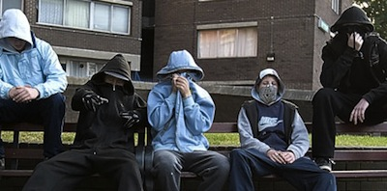
Lesson Mon 2nd November Gangs – intro
Sam was a teenager. Funny, moody, bright, lazy. At the age of 13, Sam was faced with a difficult period in his life. His Dad got a job up north so the family had to move. He had to leave his school, his friends – his whole way of life. He would miss the quietness of his small town and the simple routines. He had been to cities before but was sure that actually living in one would be very different. At his new school he struggled to make friends. People laughed at this weird accent, at his intelligence. Soon he stopped answering questions in class and became quiet and withdrawn. This made things worse – no one wanted to be friends with someone afraid to speak and the kids in year 9 already had their friends.

- Look at this picture - what can you think of when you see a gang?
- Create a mind map of reasons for joining a gang.
- Read the first part of ‘Sam’s story’

Lesson Monday 9th November Diary Task
- Read the next part of ‘Sam’s Story’
Sam missed his old world. Things had got strained at home. Mum hated where they had moved to and soon left. Dad wasn’t about much as he’d thrown himself into work. Sam started to skip school because he bored and disillusioned. Soon he got to know a couple of older kids who used to hang around the Spar shop on the top of the estate. They were funny and warm and they made him feel good – they liked his clever sense of humour and his weird accent. One day he met a lad called Davey …..who though he didn’t know it at the time would change his life forever.

- Write a diary entry that shows his
thoughts and feelings about his new life

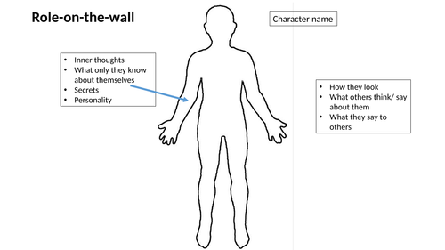
Lesson Monday 16th November Research and Role on the Wall
- Research Teen gangs online
- Create a role-on-the-wall of a character who has joined a gang.

Lesson Monday 23rd November Angel and Devil script
Sam had been knocking around with Davey and the gang for about a month now. Things weren’t much better at home. Sam hardly saw his Dad at all now because if he wasn’t working, he was with his new girlfriend and her stupid son. But that was cool with Sam – that was fine – because as Davey said: he had a new family now. One day, Sam was walking back from the park with his new crew. They stopped at a bench by the oak trees. Davey and the biggest lad in the group, Tony, said they needed a private word.
“No worries” said Sam “yeah, whatever”
“We need something doing” said Davey
“Yeah, we’re pretty strapped for cash” said Tony
“See, we know you’re pretty smart and won’t get caught” said Davey
“We know you’ll keep your cool” smiled Tony
“Hold on” said Sam “are you asking me to nick something here or what?”
Davey looked at tony and smirked, he looked older and less friendly.
“There’s this well smart bike – always parked outside the Spar shop. Belongs to a little geek that works in there. He always finishes at 8. You’re gunna get it and bring it round to Tony’s flat – we already have a buyer.
Sam nodded slowly – he felt sick and didn’t know what to do.

- Read the next part of ‘Sam’s story’ and create script that uses the ‘Devil and Angel’ technique to persuade/stop Sam from stealing the bike.

Lesson Monday 30th November Stealing the Bike storyboard
- Create a storyboard that shows events leading up to Sam stealing the bike
Lesson Monday 7th December Knife crime and letter home
- Read the final part of ‘Sam’s story’
Sam met with Davey in the park and nodded as if he had decided to go ahead with the theft. Davey embraced him and handed him a knife. Sam looked confused. “Just in case” Davey smiled. Sam smiled back – he felt like a man.
Later that evening Sam went to the Spar to steal the bike and was confronted by the owner. Sam pulled the knife out but listened to his good conscience, dropped it and ran away. His heart was beating in his mouth. He didn’t realise it but Tony and Davey had been watching him the whole time. Suddenly, he realised he was being chased by the whole gang. “Nobody lets me down”, screamed Davey. “YOU DROPPED THE KNIFE – THE POLICE WILL KNOW ITS US!” shouted Tony. Sam kept running only to realise he was at a dead end. Davey spat in his face like a pit bull. Police sirens were getting closer and the rest of the gang scattered. “We treated you like family” he was clearly drunk but his words cut deep.
The next two minutes were like slow motion to Sam. As the police walked out of the car, Davey pulled a knife from his jacket.
“Come on, man “shouted Tony “he messed up but he’s just a kid” The police charged in like lightening, the knife dropped to the floor and more police cars arrived.
In the back of the police car, Sam thought about the last 2 months of his life. Yes, he had been saved from a stabbing this time, but only for now, this wasn’t like a rescue in the films – he no Hollywood family to go back to. The cycle had started. Davey and the gang were his family now and no way would he let them down again.

- Research the penalties of knife crime
- Write a letter from Sam to his
parents from prison.

Lesson Monday 14th December Reflection and evaluation
- Create a poster which describes the skills and techniques you have used this term and how you have used them to develop your drama include - Devil and Angel/ role on the wall / storyboard/ diary entry/ mind maps. How can you apply them to your work in the future?

